OpenCPN Plugin for Compass Deviation
Draft Functional Specifications

Objective
Create a plug-in to calculate the Compass Course using True-Variation-Magnetic-Deviation-Compass (TVMDC) values.

Justification
OpenCPN does not include magnetic compass deviation tables. When a magnetic steering compass course is required the navigator must now calculate that compass course manually outside of OpenCPN.
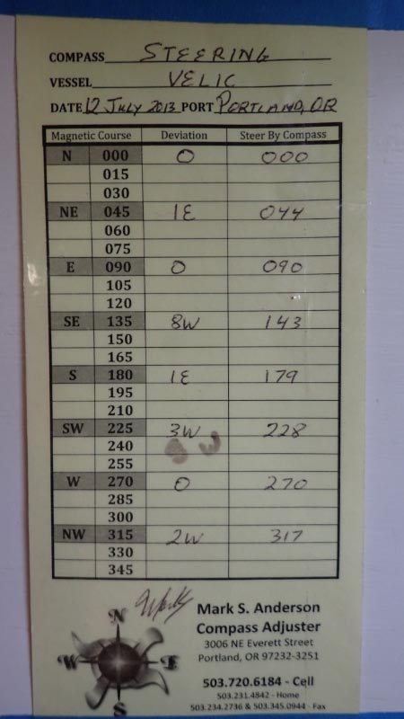
Since True, Variation, and Magnetic are already known to OpenCPN, only Deviation needs to be entered. Then calculating Compass Course (CC) is straightforward. A plugin can provide a simple user-maintained deviation table in 5° or 15° increments, as is a standard format and used in training by US Power Squadrons, USCG Auxiliary, and by compass adjusters. See attached photograph.
It may be that boaters in the age of GPS and electronic chart plotters think that a magnetic compass, and knowing the compass course, is irrelevant. However, the magnetic compass is the most reliable and fundamental navigation instrument aboard. It is more sensitive and accurate than the flux-gate compass. It does not depend upon a complex electrical supply and distribution system. Moreover on simple boats, with OpenCPN running on a laptop below deck at the navigation desk, crew are steering or setting the windvane by compass, not by chart plotter screen.

Features

User defined deviation
Allow the user to enter the deviation values into a table. A function to interpolate for unknown deviation values between known values would be a nice addition. This would assume that the compass deviation is linear between two know deviation values, but that is better than nothing. Or, run interpolation after entering all known deviation values and develop a ‘best fit’ sine curve. Clearly the more values coming from empirical observation, the better the interpolation. Warn the user that the sine curve is a theoretical best fit. Not all deviation curves are pure sine curves – there are numerous anomalies on boats.

Multiple Compasses
Allow for more than one deviation table per boat. Maybe up to N tables that can be maintained by the user.
Allow the user to name each deviation table for the compass it represents, e.g.: Binnacle Steering, Port Steering, Starboard Steering, Tell-tale (at navigation desk or near navigators berth), Fluxgate, etc. Identify the set of tables by vessel.
Most boats would use only one, but many racing sailboats have, or had, at least two steering compasses on deck, each with its own deviation card. And now many boats also have a fluxgate compass. Some new boats have two steering stations, either inside a wheel house and outside, or port and starboard wheels and binnacles.

Multiple boats
Allowing for multiple boats, with multiple tables each, is a nice feature. But not critical for most users. Ideally the user would select which boat is active in the plugin preferences settings.
Allow only one active boat at a time to ensure the correct tables are in use. Selection best made in Plugins/Preferences to ensure it is very deliberate.

Display
Display the compass course to steer in the Route dialog box when a route is active.
Selection to be made in Plugins/Preferences to ensure the correct compass is in use.
Derive the compass course from bearing (BRG) of the current leg of the route.
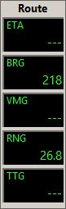
Current dialog box when a course is active:
Data element (Compass Course) added to the Tracked Course dialog box:
Route
ETA
13:20
BRG
218
CC
212
VMG
5.8
RNG
26.8

Color added for emphasis here only.

TTG
4.6

Display in the toolbar icon, similar to the WMM display, which shows the Compass Course based on: A) If a plotted course is active, then then Compass Course for the current leg, or B) current COG.
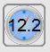
WMM Plugin:

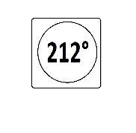
Mockup for Deviation Plugin:

Upon mouse rollover/hover the vessel and compass in use is displayed:
Steering Compass
Velic

Clearly, a better graphic artist than I should design these. I am proposing content and behavior only.

Plugin Settings and Preferences
- Select: “Create new vessel/deviation table”
  - Create new vessel or Select existing vessel
  - Create new compass deviation table
  - Populate new compass deviation table.
  - Metadata to enter with each compass deviation table:
    - “Name” of compass (Binnacle, Lucy, etc)
    - Type, make, and model of compass.
    - Date of ‘swinging the compass’
    - Location (geographic location where ‘swinging’ and adjustment were done, e.g. Lautoka, Fiji)
    - Method used (sun compass, GPS true course, gyrocompass, leading lights, fixed object bearing, etc. Empty text field, not picklist.)
    - Compass adjustments made
    - Name of compass adjuster

- Select: “Maintain existing deviation table.”
  - Select vessel
  - Select compass to use as active in route
    - Set of compasses available to select is context sensitive to vessel
  - Maintain compass deviation table.
  - Maintain metadata as above.

- Print
  - Vessel & Compass Deviation Table to text or PDF file.

Print
Print deviation tables and curves to text or PDF file. PDF would be particularly useful as an electronic document saved on the laptop running OpenCPN.

Simplicity
Roll out a robust simple deviation plugin. Get user feedback. Schedule ‘automating derivation of deviation’ for another sibling plugin – which only needs to be run infrequently, or later releases.

Companion Request
The following request is for OpenCPN development. This feature would complement the compass deviation plug-in, allowing for continued navigation when the GPS feed integrated into OpenCPN fails. I do not expect this feature to be included within development of the deviation plugin.

Own Ship Position
Manually enter own ship position, as optional. Allows for continued use of OpenCPN as navigation tool when its GPS connection fails. Many other position sources are available when the ship’s GPS fails, or fails to connect to OpenCPN. On board Velic now are: Garmin 76, Garmin 72H, iPhone 4, iPhone 5, Olympus ToughShot4 Camera. All can provide a GPS position.
A workaround is to create waypoint or drop a mark and calculate from it. But this does not take advantage of all the tools available to the ship’s own position for navigation. Hopefully these tools will include compass course from a deviation table in the near future.
Furthermore, in much coastal piloting and ocean navigation a position once per hour or each noon is more than sufficient to at least get to port safely when (not if) inter-connected GPS fails.

