Autopilot plugin for OpenCPN

Source Code

…............................................................ is coming up !

Autopilot can control a Raymarine autopilot by sending and receiving special NMEA messages to the course-computer.
For this functioning it is necessary to convert a messages from “NMEA” to “SEATALK”. For this conversion a special hardware is required.
(Seatalk – NMEA converter, Seatalk-link )
The hardware can be ordered here : http://www.gadgetPool.de
It is tested with a Raymarine Smartpilot S1G an a ST6002+ Panel. But I think it would work with others too.

Install the plugin in accord with the Install and Enable Instructions. After that activate the plugin.

Autopilot Dialog:

klick on Autopilot Icon in toolbar to show the Autopilot control-panel.
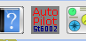

Autopilot Control-panel :

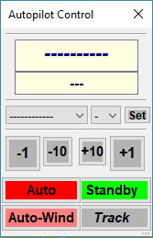

Status of Autopilot

MAG compass or Autopilot Course.

( shown, when there is no data from the Course-computer )

When the Control-panel looks like this, the push on the Buttons has no effect.

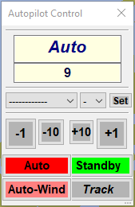
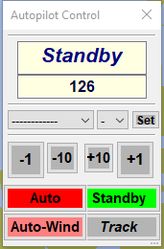
(Autopilot in Auto Mode) (Autopilot in Standby Mode)

The Control-panel can be used like a Raymarine panel like for example ST6002. But not everything can be done.
The following functioning is given:
Go from “Standby” to “Auto” or “Auto-Wind” Mode. When the Autopilot is in “Standby” Mode, the Increment and Decrement Buttons have no effect.
The “Track” Button has only an effect, when the Autopilot is in “Auto” Mode.

The “Response”, “Wind-Trim” and “Rudder-Gang” Parameters can be set to a Value.
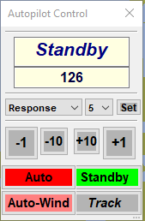
When one of the Parameters is selected, the default Raymarine Value
shown. (It is not known the Value that is set in the course-computer in
the moment ). By bushing the Button Set, the Value will be send to the
course-computer. The Changes will be shown on other Display for 5
Seconds.

NMEA Messages from an to Autopilot will be translated to SEATALK by SeatalkLink (Seatalk NMEA Converter )
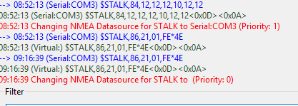
Outgoing same message.
incoming message from course
computer.

outgoing message.

All messages named “$STALK,.....”. This is the Sentencename that will be understood by the Seatalk NMEA Converter for translating it to SEATALK messages.
The Sentencename can be changed in the Autopilot plugin preferences. The reason is, you see, that OpenCPN is sending every incoming message on the same COMx back although it comes from here. That makes traffic. ( Bug in OpenCPN ? ).

The Preference Dialog from Autopliot Plugin

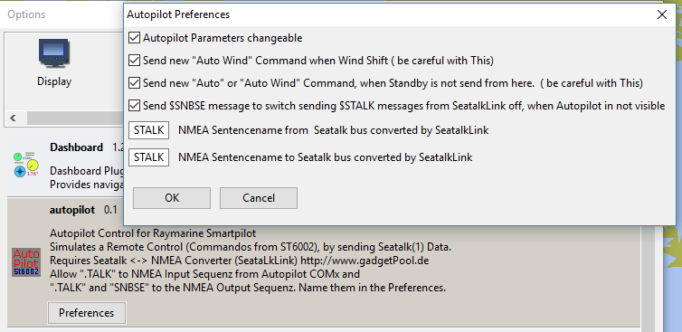
Description :

- Turning off the visibility of the “Autopilot Parameters” like “Response”, “Wind-Trim” and “Rudder Gain” in the Autopilot Control-panel. So you could not change them.
- It is able to send a new “AUTO-WIND” sentence to the Autopilot if there is a Wind-Shift. But be very careful with this feature. You turn off the Raymarine security ! ( The reason I implemented this is, that I often use “Auto-Wind” when there is low Wind, and I am too lazy to push the “Auto Butten” several times.)
- Sending a new “AUTO” or “AUTO-WIND” sentence when the signal for going to “Standby – Mode” is not coming from the Autopilot Plugin. Also be very careful with this feature for your security. The reason I implemented this is, when I used the Autopilot for hours, my course-computer has gone to “Standby” without a reason. So if you don't have hat this problem any time, I think you would not need. (feature is not tested yet)
- $SNBSE is a NMEA sentence to control the Seatalk NMEA Converter. It is able to switch off the sending of $STALK massages. (Not so much traffic on com Port)
- Rename the NMEA Sentencename coming from the gadgetpool Seatalk NMEA Converter.
- Rename the NMEA Sentencename sending the gadgetpool Seatalk NMEA Converter. When the Sentencenames are different, it is able to implement a filter in OpenCPN so that the sentences are not send back.

